**Project paper**

**on**

**Software development**

## Project name:

Tex – The Text Editor

# Course Info:

Course No: CSE 2100   
Course Title: Software Development - 2

# Moderated by:-

Ms. Monjura Afrin Rumi

Lecturer,

Ahsanullah University of Science & Technology

# Project by:-

* Al Masum Fahim
  + ID: 12- 02- 04- 027
* Farhana Yasmin
  + 12- 02- 04- 027

Project Description:

In this project, we have made a Text Editor which is designed to provide the power and functionality to satisfy the most demanding text editing requirements.

Used Software:

## Netbeans 7.4

## JDK 7

# Features :

* **Word count**
  + In this note pad we have included a feature that will help you to know the number of word you have written in the text
* **Letter count**
  + The software will also count the number of letters
* **Line count**
  + We have added a feature that will show you the line numbers at the left side.
* **Word search**
  + It will search any desired word that exists in the text and colors that word.
* **Copy, cut and paste(CCP)**
  + Cut, copy, paste options are available in this software.

**Screenshots:**

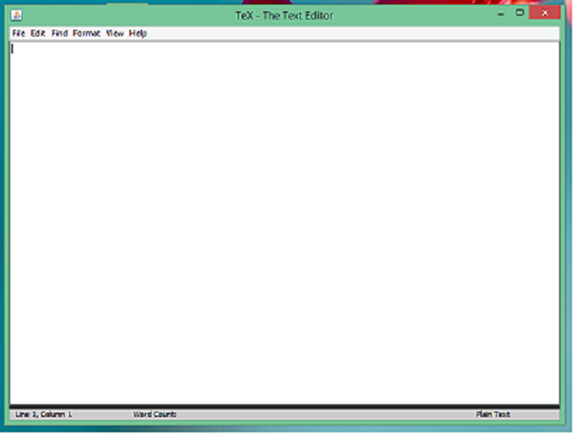

This is the first look of ‘Tex – The Text Editor’. When the software starts, this page comes first

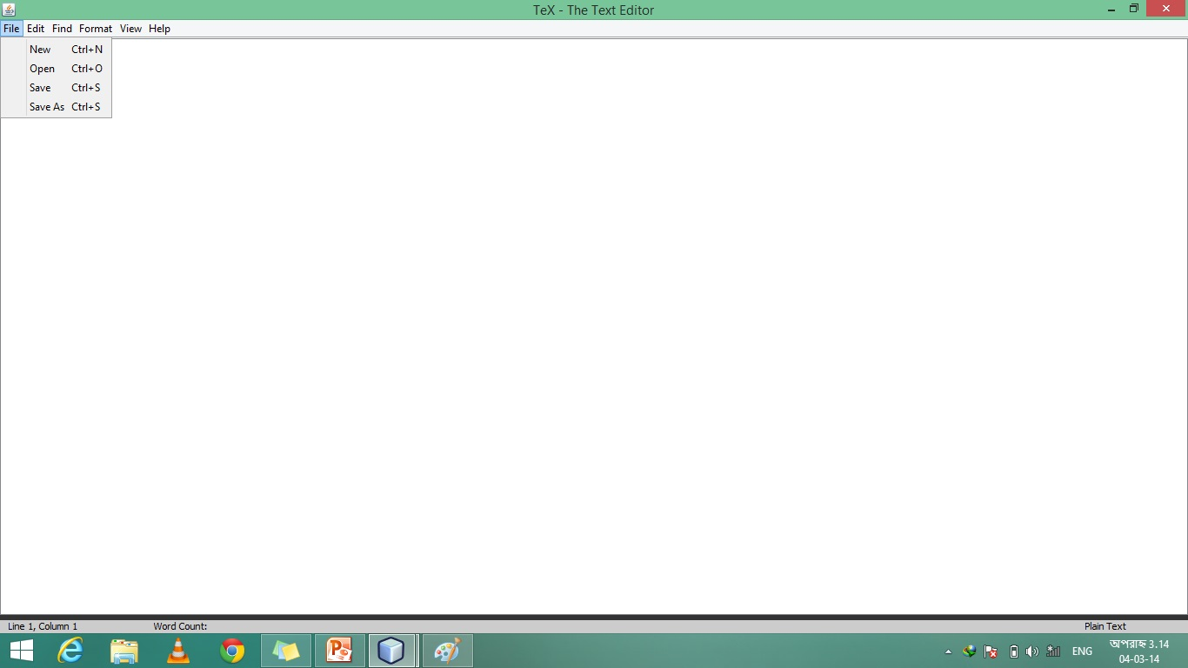

It saves the text in .txt format in any desired location

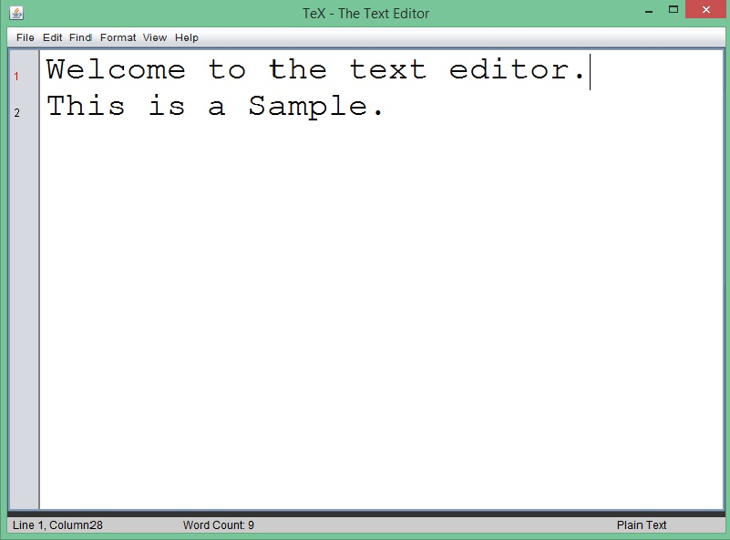

This is the sample look of ‘Tex- The Text Editor’

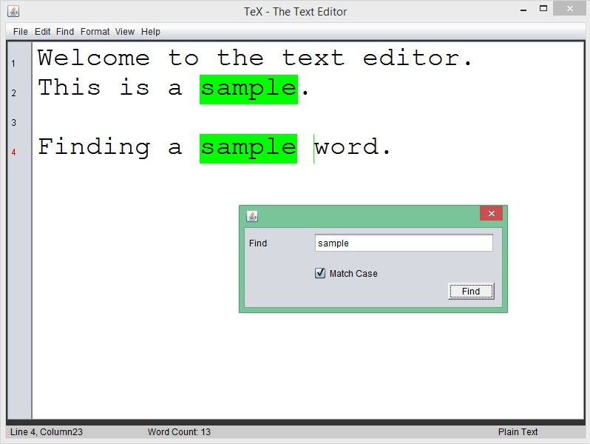

This is the operation of finding a word

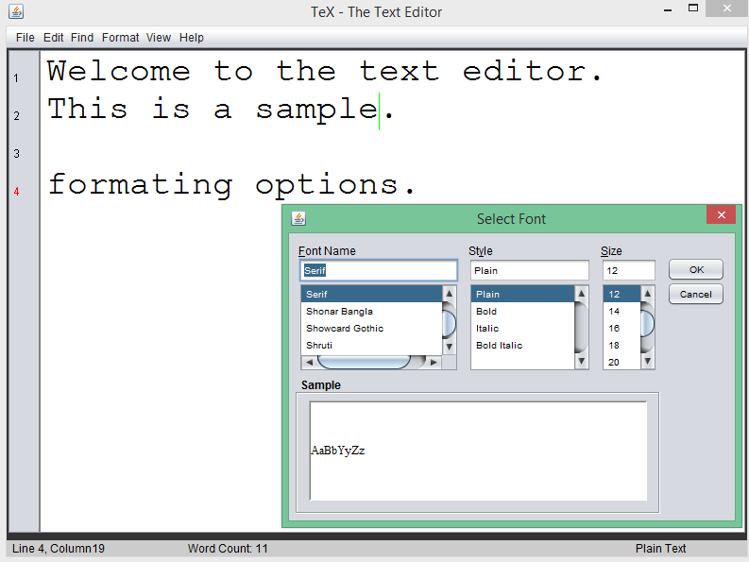

This is the look of the software when you wanted to change the fonts.

**Conclusion:**

We hope everyone enjoyed what you just saw right now. The program is quite easy to understand and even easier to operate.

We hope that the program will be really helpful for everyone. Thanks a lot for giving us the valuable time.

Thank you.